Writeup for DGCL Event

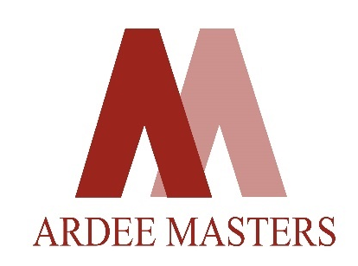
Team Ardee Masters is owned by the renowned “The Ardee School” New Delhi which is the first school to own a golf team.

A part of the reputed real estate development firm “The Ardee Group”, The Ardee Schools founded in 2003, are award winning International K-12 schools in Delhi, Gurugram and Goa.

At The Ardee School, conventional academic teaching methods had been long discarded. However, as in most schools, the sports curriculum remained orthodox - basketball, soccer, cricket swimming are the only norm, especially since space to teach golf is a challenge in city schools.

Not to be deterred, Ardee, in its true Ardee way, found that the D.G.C league could be the perfect bridge to expose Ardee students to the sport of golf which teaches important life skills to students such as concentration, teamwork and networking. The endeavour at Ardee is to encourage students to include golf in their sports vocabulary by watching, exploring, understanding, and eventually wishing to play the game with their own golf team - Ardee Masters.

